**Smart Irrigation System**

**BACHELOR OF TECHNOLOGY**

(Robotics & Artificial Intelligence)



## SUBMITTED BY:

Name: Aditya Kumar Tiwari Name: Aman Kumar Name: Ankit Vats

Roll no: 2231197 Roll no: 2231199 Roll no: 2231202

**Under the Guidance of**

Ms. Tanya Gupta

(Assistant Professor)

# Department of Computer Science & Engineering Chandigarh Engineering College Jhanjeri Mohali - 140307

## Table of Contents

|  |  |  |
| --- | --- | --- |
| **SNo** | **Contents** | **Page No** |
| 1. | Introduction | 03 |
| 2. | Literature review | 04 |
| 3. | Problem formulation | 04 |
| 4. | Objectives | 05 |
| 5. | Methodology | 06 |
| 6. | Facilities required | 07 |
| 7. | References | 08 |

## Introduction

Smart irrigation systems are automated mechanisms designed to optimize water usage in agricultural applications using IoT technology, sensors, and machine learning algorithms. These systems improve water efficiency, reduce wastage, and enhance crop yield by delivering the right amount of water at the right time.

**1.1 Need for Smart Irrigation System**

With increasing global population and water scarcity, there is a growing need for optimized water management systems. Traditional irrigation methods result in excessive water wastage, which can be controlled by smart irrigation systems through automated techniques.

**1.2 Applications of Smart Irrigation**

* Agriculture fields
* Greenhouses
* Parks and public gardens
* Golf courses
* Domestic gardens

**1.3 Advantages of Smart Irrigation**

* Water conservation
* Cost efficiency
* Automated control
* Improved crop yield
* Remote monitoring

**1.4 Challenges in Traditional Irrigation**

* Water wastage
* High operational costs
* Inefficient resource utilization
* Dependency on manual labour
* 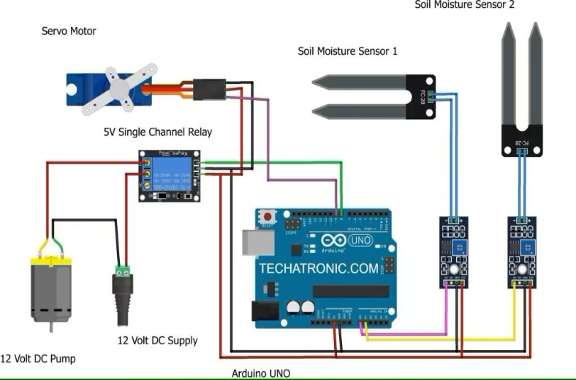

## Literature Review

Various research papers and studies have demonstrated the importance of smart irrigation systems in modern agriculture. Traditional irrigation systems such as flood irrigation and manual sprinkler systems require significant water resources and manual intervention, leading to inefficiency and wastage. Recent developments in IoT-based systems have improved water conservation by integrating sensors to monitor soil moisture, temperature, and humidity. IoT systems transmit this data to cloud platforms, enabling remote monitoring and automatic irrigation scheduling. Machine learning algorithms are increasingly applied to predict soil moisture levels and weather patterns, allowing more accurate irrigation decisions. Techniques such as decision trees, neural networks, and regression models enhance system efficiency. Additionally, water conservation methods like drip irrigation, rainwater harvesting, and real-time sensor feedback have been integrated into smart irrigation systems to maximize efficiency and minimize water loss.

## Problem Formulation

**3.1 Need for the System**

Traditional irrigation methods lead to excessive water consumption, affecting water availability and agricultural productivity. Manual irrigation lacks precision, resulting in overwatering or underwatering, which impacts crop health and yield. Additionally, factors such as changing weather conditions and soil moisture levels are not efficiently considered in conventional methods. These limitations necessitate a smart irrigation system that optimizes water usage while ensuring optimal crop growth.

**3.2 Irrigation Challenges**

1. **Water Wastage:** Traditional irrigation methods often lead to excessive water consumption due to a lack of real-time monitoring and control.
2. **Inefficient Water Distribution:** Farmers struggle to maintain optimal soil moisture levels, leading to either overwatering or underwatering.
3. **Dependence on Manual Intervention:** Manual irrigation requires constant monitoring and effort, making it labour-intensive and inefficient.
4. **Lack of Data-Driven Decision-Making:** Traditional methods do not utilize real-time data from environmental factors such as soil moisture, temperature, and humidity.

**3.3 Proposed Solution**

The proposed smart irrigation system automates the irrigation process using IoT sensors and machine learning algorithms to optimize water consumption and improve crop yield. The system will:

* Monitor soil moisture, temperature, and humidity in real-time.
* Automate irrigation based on environmental data and predefined thresholds.
* Reduce water wastage by ensuring precise and need-based irrigation.
* Provide farmers with data-driven insights for better decision-making.

## Objectives

## The development of a Smart Irrigation System to Optimize Water Usage Using IoT and Machine Learning is guided by several critical objectives. These objectives are designed to ensure that the system addresses the pressing issues of water conservation, efficient resource management, and improved agricultural productivity. The following objectives outline the essential functionalities and benefits of the system:

## Design a smart irrigation system with IoT sensors.

## Automate irrigation based on environmental data.

## Optimize water usage through machine learning algorithms.

## Enable remote monitoring through cloud platforms.

## Improve crop yield while conserving water resources.

## Minimize human intervention through automated decision-making.

## Utilize cloud storage to maintain historical data records.

## Enhance scalability for different agricultural field sizes.

## Develop a mobile application for remote user control and notifications.

## Implement predictive analytics for weather-based irrigation adjustments.

## Reduce operational costs through efficient water resource management.

## Ensure system adaptability for various crop types and environmental conditions.

## Enhance system security through encrypted data transmission.

## Integrate renewable energy sources such as solar panels to power the system.

## Methodology

## 5.1 System Architecture

## The proposed system includes IoT sensors, microcontrollers, cloud storage, and machine learning algorithms.

## 5.2 Hardware Description

## Soil moisture sensors

## Temperature sensors

## Humidity sensors

## Microcontroller (Arduino/NodeMCU)

## Water pump

## 5.3 Software Description

## Arduino IDE

## Python

## Firebase for cloud storage

## TensorFlow and Scikit-learn for machine learning

## 5.4 Data Flow Diagram

## A flow diagram will illustrate how data flows from sensors to cloud servers and how decisions are made for irrigation.

## Flowchart for Smart Irrigation System:

## 

## 5.5 Algorithm for Irrigation System

## Collect sensor data.

## Analyse data using machine learning models.

## Predict soil moisture levels.

## Activate water pump if required.

## Transmit data to cloud storage.

## Facilities Required

## To successfully develop the Smart Irrigation System, a specific set of facilities encompassing both hardware and software components is essential. These resources will ensure that the project can be executed effectively and that the final product meets the required standards of accuracy and performance.

## 6.1 Hardware Requirements

## The hardware requirements for this project include:

## Microcontroller Board (Arduino/NodeMCU): Serves as the central processing unit to control the entire irrigation system.

## Soil Moisture Sensors: Measures the moisture content in the soil to determine if irrigation is needed.

## Temperature Sensors: Monitors the ambient temperature to optimize irrigation schedules.

## Humidity Sensors: Records atmospheric humidity for better environmental analysis.

## Water Pump: Automatically irrigates the field when instructed by the system.

## Power Supply: Provides necessary electrical power to run the sensors and microcontroller.

## Relay Modules: Controls the activation and deactivation of the water pump.

## Water Flow Sensors: Monitors the flow rate of water during irrigation.

## Solar Panels (Optional): Renewable energy source for powering the system.

## 6.2 Software Requirements

## The software requirements involve a combination of programming libraries and tools that will support the development and testing phases:

## Arduino IDE: For programming the microcontroller and interfacing with hardware components.

## Python with TensorFlow/Scikit-learn: Used for building and training the machine learning models.

## Firebase Cloud Storage: Stores sensor data and system logs for remote monitoring.

## OpenCV: Helps in data visualization and additional image-based analysis.

## Postman: Used for testing API interactions and cloud-based communications.

## Flask/Django: Backend frameworks for developing the web-based admin dashboard and API integration.

## MySQL/MongoDB: Databases for securely storing sensor data and logs.

## References

* *Smith, J. (2022). "IoT-Based Smart Irrigation Systems." International Journal of Agriculture Technology.*
* *Patel, R. (2023). "Machine Learning Applications in Agriculture." IEEE Transactions on Smart Agriculture.*
* *Kumar, P. (2021). "Water Conservation Techniques Using IoT." Journal of Environmental Studies.*
* *Williams, T. (2024). "Smart Irrigation Systems and Their Impact on Water Conservation." IEEE Transactions on Agriculture Technology.*
* *Ahmed, R. (2022). "Cloud-Based Monitoring Systems for Irrigation." Journal of Cloud Computing and IoT.*
* *Chen, Y. (2023). "Role of IoT in Sustainable Agriculture." Journal of Agricultural Innovation.*